July 29, 2020

Mining Association of Canada 1105 – 350 Sparks Street Ottawa ON K1R 7S8

ATTENTION: Mr. Pierre Gratton, President and Chief Executive Officer, Mining Association of Canada

REFERENCE: Sudbury Integrated Nickel Operations A Glencore Company - Towards Sustainable Mining
(TSM) Verification
____________________________________________________________________________________

Sudbury Integrated Nickel Operations has a process in place to verify the information provided to the Mining Association of Canada ("MAC") with respect to its Self-Assessed Towards Sustainable Mining ("TSM") Performance Indicators.

The “TSM Verification Process” included an independent review performed by Blue Heron Environmental. The Verifiers reviewed the process developed and implemented by Sudbury Integrated Nickel Operations for the year ended December 31, 2019 with respect to the TSM self-assessment information entered into the Mining Association of Canada’s Towards Sustainable Mining (“TSM”) online database. The Verifiers assessed the company's reported TSM performance indicator results as measured against the requirements of MAC’s Towards Sustainable Mining Performance Indicators.

The results submitted on line reflect the verified results.

Please feel free to contact Moe Moreau (705) 929-5469 if you have any questions regarding the 2019 results.

Sincerely,

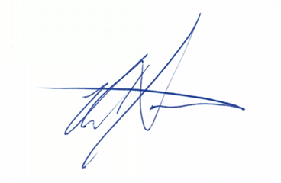

Peter Xavier
Vise President
Sudbury Integrated Nickel Operations
A Glencore Company

cc: - Jennifer Gibbs, Manager Sustainability - Moe Moreau, EMS Lead

